22.5: a)
b) We would get the same flux as in (a) if the cylinder’s radius was made larger—the field lines must still pass through the surface.
c) If the length was increased to 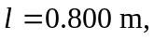 the flux would increase by a factor of two: 